**Name:- Dharan Gowda Superset id:-6387532**

**Step 1: Setup your machine with Git Configuration**

To create a new repository, signup with GitLab and register your credentials

Login to GitLab and create a “GitDemo” project

**1)Check Git is installed:**

git –version

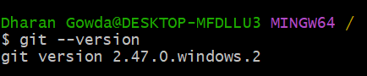

**2) Configure Git username and email**

git config --global user.name "dharan gowda"

git config --global user.email [dharangowda296@gmail.com](mailto:dharangowda296@gmail.com)

**3) Verify configuration:**

git config --list

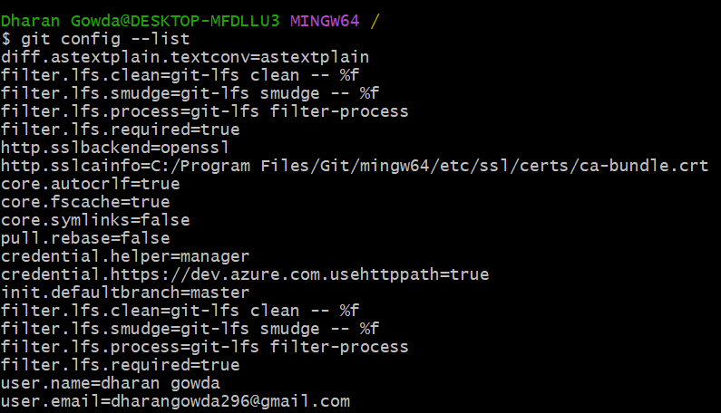

**Step 2: Integrate Notepad++ with Git Bash**

**1)** **Check if Notepad++ works from Git Bash:**

notepad++

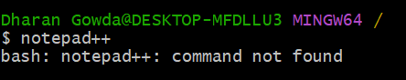

Adding path to the system **Environment Variables**:

* Control Panel → System → Advanced system settings → Environment Variables

**2)Restarting Git Bash**, then check again

**3)Create an alias:**

alias npp='"/c/Program Files/Notepad++/notepad++.exe"'

**4)Make Notepad++ the default editor for Git:**

git config --global core.editor "'C:/ProgramFiles/Notepad++/notepad++.exe' -multiInst -notabbar -nosession -noPlugin"

**5)Verify default editor**

git config --global –edit

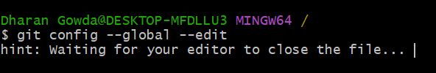

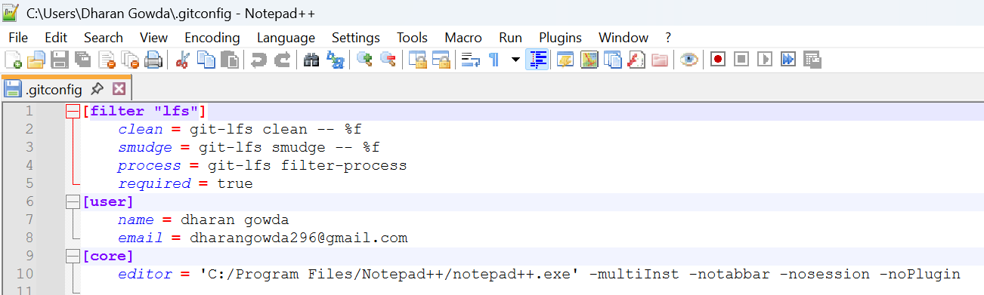

**Step 3: Add a File to a Source Code Repository**